Opinion: Before Alaska becomes an AI data farm, be sure to read the fine print

By Roger Kaye
Published: ADN
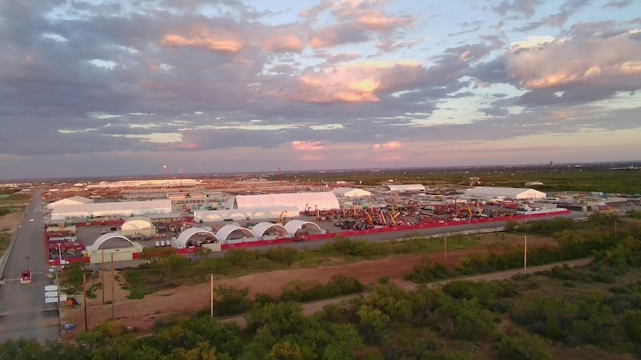The Stargate artificial intelligence data center complex in Abilene, Texas. (AP)

Artificial intelligence is driving a revolution in the economy and culture of the United States and other countries. Alaska is being pitched as the next frontier for one of the most energy-intensive industries: data centers, with their primary purpose of advancing AI, socially disruptive to a degree as yet unknown.

Gov. Mike Dunleavy, the state’s biggest promoter, has invited more than a dozen high-tech firms, including affiliates of Microsoft, Facebook and Amazon, to establish “data farms” in Alaska. He has personally toured executives around potential sites in the Anchorage and Fairbanks areas. The Alaska Legislature has been a bit more circumspect, though its House Concurrent Resolution 3 (HCR 3) states that “the development and use of artificial intelligence and the establishment of data centers in the state could stimulate economic growth, create job opportunities and position the state as a leader in technological innovation.” True, however, the resolution makes no mention of drawbacks stemming from data center development.

The Northern Alaska Environmental Center (NAEC), based in Fairbanks, is examining the known and potential benefits, costs and risks of data center growth in the state. It urges a well-informed, unhurried, transparent and cautious approach.

First, though, what are data centers? They are facilities that house the servers, storage, networking and other computing infrastructure needed to support AI and other digital services, along with their associated electrical and cooling infrastructure.

Generally speaking, there are two categories of data centers. One is the massive hyperscale facility, typically operating at multi-megawatt scale and designed to scale much higher. An example is the proposed Far North Digital (FND) Prudhoe Bay Data Center. It would start with a capacity of 120 megawatts with “significant expansion potential.” Natural gas would power it.

The other kind is the micro or microgrid data center. A good example is Cordova’s Greensparc Corp/Cordova Electric Cooperative 150-kilowatt facility. It is powered by 100% renewable energy from the nearby hydroelectric plant. We concur with the University of Alaska Fairbanks’ Alaska Center for Energy and Power (ACEP) analysis that contends that such smaller and sustainable data centers, sometimes integrated into existing microgrids, are more feasible for Alaska, particularly in underserved or remote communities.

The main problem with data centers is their high to huge energy demands, especially hyperscale ones that can consume as much electricity as 100,000 homes. Cooling can account for about 40% of a facility’s energy use, though it varies. While Alaska’s cold climate is an environmental advantage, reducing the need for energy-intensive mechanical cooling systems, cooling still requires a lot of water. The NAEC advocates that any new data centers be required to minimize use and thermal pollution of waters and reuse waste heat for local heating.

The Railbelt grid already faces constraints and expensive upgrade needs. The NAEC believes that if new data centers are developed, regulatory safeguards must be in place to ensure they do not exacerbate grid shortages and raise household electricity costs.

Most electricity powering data centers still comes from fossil fuels, even as operators sign renewable contracts and add clean generation. Building fossil fuel-powered data centers would lock in high-emissions infrastructure for decades, contradicting global decarbonization efforts. NAEC suggests that any new data center be required to build or contract for an equivalent amount of clean energy generation (wind, solar, hydro or geothermal) to match its consumption.

There are many other concerns that need to be addressed when considering data centers and AI development. One is the problem of electronic waste, or e-waste. Needed upgrades to data centers result in e-waste, which contains hazardous materials. Given Alaska’s remote potential sites and limited recycling infrastructure, the cost of appropriately dealing with e-waste should be factored into data center decisions.

In their haste to recruit data centers, several states have granted substantial tax abatements and subsidies, often with limited public benefit. Alaska must learn from the mistakes made elsewhere. Before considering approval of any new data centers, legislation should be in place that ensures that the corporations that will profit do not get discounted power rates or tax breaks and pass additional costs to ratepayers, including costs for needed upgrades.
Yes, data centers provide some much-needed diversification to Alaska’s economy, but not much. They are highly capital intensive and employ many in the construction phase, but few for operation. Companies should be required to train and hire local residents to the degree practical.

Then there is the profound but scarcely recognized issue that transcends energy, economics and the environment. Data centers expand the compute available for increasingly capable AI systems. Some researchers and industry leaders argue this could accelerate progress toward AI that matches or exceeds human capabilities, along with new risks. Ultimately, the greatest cost of data centers and AI may be the changes wrought to our humanity and society, for which we are woefully unprepared.

Roger Kaye is a freelance writer based in Fairbanks and the author of “Last Great Wilderness: The Campaign to Establish the Arctic National Wildlife Refuge.” He sits on the Issues Committee of the Northern Alaska Environmental Center.
• • •

